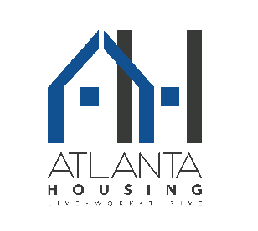
AHA CANDIDATE INFORMATION FORM
Intern Job Fair: Tuesday - April 17, 2018
4 :00 p.m. – 7:00 p.m.
230 John Wesley Dobbs Avenue
Atlanta, Georgia 30303
Candidate Name (Please print)
Email Address: (Please print)
Phone:
-----------------------------------------------------------------------------------------------------------------------------------
- Please complete this form, attach a current resume and bring both documents with you to the job fair on Tuesday - April 17, 2018
- Also, please ensure you have submitted an electronic version of your resume to: AHAinterns@atlantahousing.org
- Are you currently a rising senior in high school? Yes ____ No ____
- Have you applied and been accepted into college? Yes___ No____
- Please check year in college: 1st _____ 2nd_____ 3rd_____ 4th_____
- Are you a current resident of affordable housing or housing choice? Yes____ No____
- Community Name: ________________________________________________________
- Voucher holder’s name: Last _____________________ First________________________________
- Voucher holder’s Phone: _______________________
- Have you ever been employed by Atlanta Housing? Y____ N____ Date: ___________

Rank your top 3 areas of interest as 1st, 2nd, and 3rd
(These areas are representative of the available opportunities)
- Contracts & Procurement (Interested in the public buying function, exposure to contracts)
- Choice Neighborhoods (Interested in social work/human development/community engagement)
- Communications & Public Engagement (Interested in communications & public relations)
- Governmental & External Affairs (Interested in public policy, local government, neighborhood planning, senior citizen initiatives)
- Facilities Management (Interested in accounting and the operation of a corporate facility)
- Finance (Interested in accounting & finance)
- Human Development Services (Interested in social work & human development)
- Information Technology (Interested in programming, PC service & repair, telecommunications)
- Real Estate Group
- Real Estate Oversight & Services (Interested in professional property management, process improvement initiatives, utility management)
- Neighborhood Revitalization (Interested in affordable housing, and economic vitality within communities)

Please list any classes or work experience relevant to your selections above

Class or other training | Details

All applicants must pass a comprehensive background check and drug screen
AHA is an Equal Opportunity Employer

